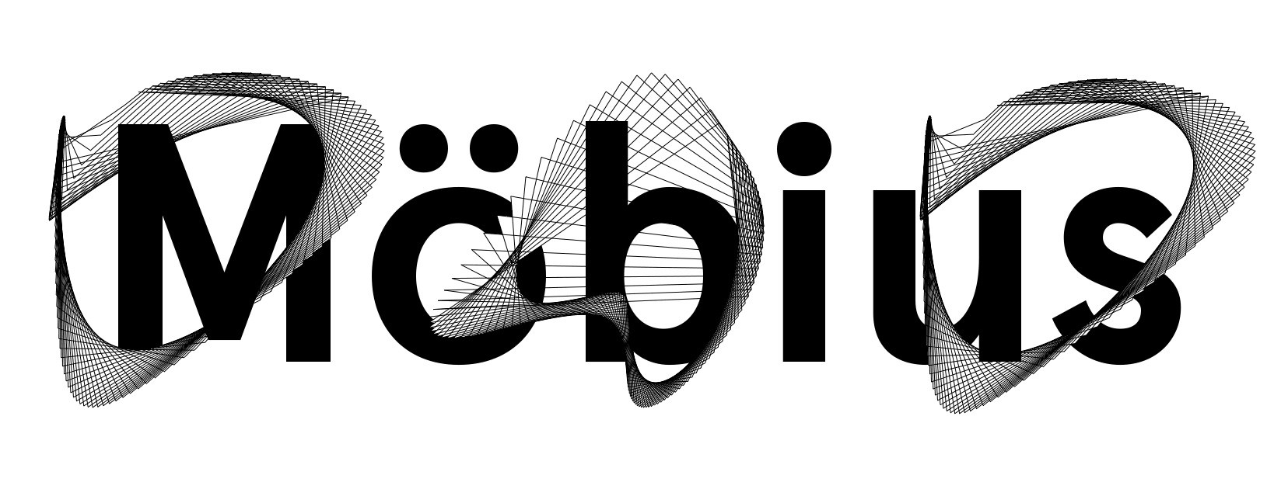

EQUAL OPPORTUNITIES MONITORING FORM

All the information you provide here will be kept confidential, used only for monitoring purposes and stored separately to your application.

Möbius Dance consistently works to ensure that all its employment processes reflect the diversity of contemporary England. We would appreciate knowing certain information about people who are applying to work with us, as this helps us to check whether our procedures are fair.
We would be grateful, if you could complete this form.

Please tick or highlight as appropriate

Ethnicity

Asian / Asian British

Indian

Bangladeshi

Any other Asian background

Pakistani

Chinese

Black / Black British

African
Any other Black background

Caribbean

Mixed

White and Black Caribbean

White and Asian

White and Black African

Any other Mixed/Multiple ethnic background

White

British

Irish

Gypsy/Irish Traveller

Any other White background

Other
Arab

Any other ethnic group

Not known / Prefer not to say

Age

 18-28 56-64

 29-40 65+

 41-55

Gender

Female

 Male

 Non-Binary

 Prefer not to say

Sexual Orientation

 Bisexual Gay man

 Heterosexual Other / Prefer not to say

 Gay woman

Gender Identity: Do you identify as transgender/transsexual

 Yes

 No

 Prefer not to say

Disability
The Equality Act 2010 defines a disability as a “physical or mental impairment” which has a substantial and long-term adverse effect on a person’s ability to carry out normal day to day activities”. An effect is long-term if it has lasted, or is likely to last, more than 12 months.

Do you consider yourself to have a disability?

Yes No

